

**Proposal and Quotation for Digital Marketing Services**

<https://www>.veloxn.com

**Introduction –**

Thank You for showing interest in Veloxn Private Limited for Digital Marketing services requirement.

**Service Cost -**

The table below details the cost associated with this service.

|  |  |  |  |
| --- | --- | --- | --- |
| **Name** | **Unit Price** | **Month** | **Subtotal** |
| Managing and posting at Social Accounts  LinkedIn Ads Services  20% of monthly spending, minimum Rs 5000 per month | ₹5000 | 1 | ₹5000 |
|  |  |  |  |
| **SUBTOTAL** |  |  | ₹5000 |
| GST 18 % |  |  | ₹900 |
| **TOTAL Including GST** |  |  | **₹5,900** |

Payment required is **₹ 5,900**

**Note\*** - Offer Valid for 7 days only/-

**Bank Details**:

**VELOXN PRIVATE LIMITED**

AC Number – 259958439076

IFSC Code – INDB0000702

Bank Name – Indusind Bank

UPI ID - veloxnservices@okicici

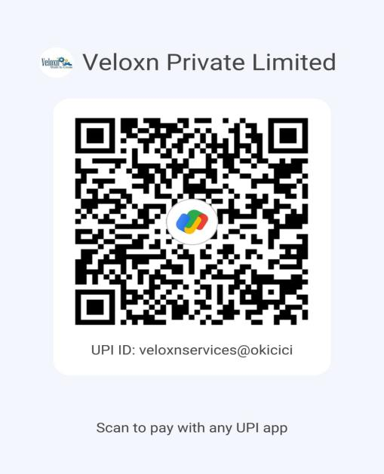

**COMPANY:**

Veloxn Private Limited

Iconic Tower C, Corenthum, Sector-62, Noida, UP - 201301, India www.veloxn.com

sales@veloxn.com

91-7292001010

GST - 06AAICV7138B1ZE